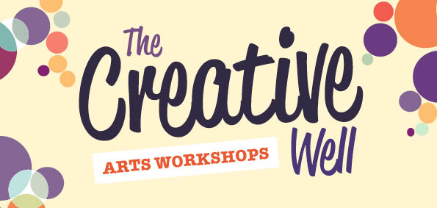
Application Form
Name:

Address:

Telephone: Email:

Do you agree to take part in an evaluation of the programme Yes□No□

Do you give consent for any visual images taken and for their use Yes □ No □

Do you wish to be added to our mailing list to be informed of future programmes and opportunities with The Creative Well Yes □ No □

The aim of this programme is to develop a new approach to supporting wellbeing through the arts and within the context of local communities.

Please note that as places are limited, preference will be given to those who don't have opportunity to participate in the arts due to health, financial, or social circumstances.

The Creative Well is an initiative of Kildare Arts in Health supported by HSE Kildare West Wicklow Mental Health Services, Kildare County Council Arts Service, HSE Health Promotion, Kildare County Mental Health Association and Kildare County Council Library Service.

Please return this form to: Catherine O Grady
Creative Well Programme
St. Marys
Craddockstown Rd
Naas
Co. Kildare

